Joint-Project Design Document

**Game Description:**

Patrick starts the game at the menu with the information of how to play. There is also the start game button which once the space bar is pressed will enter the player into the game. `

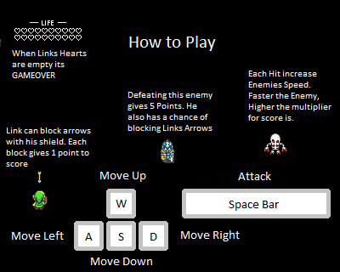The player model will start at the centre of the screen and an enemy will be spawned in (created) infront of the pipe whilst four enemies will shot at the player in random sequence. By using the w,a,s,d buttons Patrick dodges the incoming arrows and the advancing enemy. Once the enemy is hit with by the player a specific number of times (indicated by the number of hearts over the enemies head) the enemy will die and respawn only this time faster. The players score, shown at the top of the screen, is increased by collecting rupees from the killed enemies. Once Patrick is hit a number of times indicated by the number of hearts he has the screen changes to the game over screen where it displays his score and the number of enemies defeated. If Patrick chooses so by pressing R indicated on the screen he can start a new game.

**Game Genre:**

This game is a top down action-adventure game. Another example of this genre is The Legend of Zelda Phantom Hour Glass. The two games have the same player perspective where the player is looking down at the gameplay. The both games have the same idea of the player shooting and killing enemies to receive rupees or points. Where the games differ is that the Phantom Hour Glass has a wider map whereas my game is more of a surviving waves of enemies until the player dies.

**Goals:**

The player’s goals are to earn as many rupees as they can and to survive as long as they can. He is stopping these monsters from attacking the nearby innocent village from being attacked. If he runs out of lives by being hit by the monsters he dies and the village is destroyed.

**Player:**

The player is moved using the W, A, S, D keys. He shoots arrows at the enemies to kill them. As the game continues the player will receive posts like extra health or damage boost. If the player is hit (collides) with the player , he loses health until he dies so moving around is key.

**Enemies:**